Resource impacts of ePortals for general practices - Summary
Tom Love, Rohan Boyle
14 May 2015

About Sapere Research Group Limited
Sapere Research Group is one of the largest expert consulting firms in Australasia and a leader in provision of independent economic, forensic accounting and public policy services. Sapere provides independent expert testimony, strategic advisory services, data analytics and other advice to Australasia’s private sector corporate clients, major law firms, government agencies, and regulatory bodies.

Wellington  Level 9, 1 Willeston St  PO Box 587  Wellington 6140  Ph: +64 4 915 7590  Fax: +64 4 915 7596 | Auckland 1  Level 17, 3-5 Albert St  PO Box 2475  Auckland 1140  Ph: +64 9 913 6240  Fax: +64 9 913 6241 | Auckland 2  Level 1, 441 Queen St  PO Box 2475  Auckland 1140  Ph: +64 9 354 4388 |  | Sydney  Level 14, 68 Pitt St  GPO Box 220  NSW 2001  Ph: +61 2 9234 0200  Fax: +61 2 9234 0201 | Canberra  Unit 3, 97 Northbourne Avenue  Turner ACT 2612  GPO Box 252  Canberra City, ACT 2601  Ph: +61 2 6267 2700  Fax: +61 2 6267 2710 | Melbourne  Level 2, 65 Southbank Boulevard  GPO Box 3179  Melbourne, VIC 3001  Ph: +61 3 9626 4333  Fax: +61 3 9626 4231

For information on this report please contact:
Name: Tom Love
Telephone: +64 4 915 7590
Mobile: +64 21 440 334
Email: tlove@srgexpert.com

Contents

1. Introduction 1
1.1 Background 1
1.2 General approach 1
1.3 Reported Results 2
2. Scenario Analysis 3
Scenario 1: Baseline 3
Scenario 2: Change in substitution 4
Scenario 3: Change in “clinical queries” 5
Scenario 4: Cost-recovery models 6
3. Main points 7

Tables
Table 1 Scenario 1 assumptions 3
Table 2 Summary results 3
Table 3 Scenario 2 assumptions 4
Table 4 Scenario 3 assumptions 5
Table 5 Scenario 4 assumptions 6

Figures
Figure 1 Change in net gains conditional on patient uptake and practice size 3
Figure 2 Change in GP FTE conditional on the rate of substitution 4
Figure 3 Change in net gains conditional on the rate of substitution 4
Figure 4 Change in GP FTE conditional on the number of clinical queries per patient 5
Figure 5 Change in net gains conditional on the number of clinical queries per patient 5
Figure 6 Financial outcomes under a subscription fee model 6
Figure 7 Financial outcomes under a pay-as-you-go model 6

Introduction

Background
Patients First is working with the National Health IT board to develop support for practices to make effective use of patient portals. As one component of this work, Sapere Research Group was commissioned by Patients First on behalf of the National Health IT Board to model the impact of patient portal implementation on general practices costs and revenues.
A patient portal is a secure online tool for patients to access their health information and interact with their general practice. Patient portals have the potential to streamline a number of clinical processes and improve practice communication with stakeholders.
However, some stakeholders in the primary care sector are unclear about the financial and workload impacts of implementing portals.
The purpose of the modelling is to better understand how patient portals affect general practices by identifying where benefits can be realised and quantifying the amount. The results from the modelling are intended to support a more informed discussion and give general practices guidance about effective options for implementation.
This paper complements a broader report which provides the details about the process and results of the modelling. The focus is firmly on the modelled results rather than the process followed to derive the results. It is intended this report provides an overview of the results that is meaningful to a wider audience.

General approach
Our analysis of portal implementation involved three steps:
- step one: background research
- step two: design and assumptions
- step three: resource modelling
We interviewed key stakeholders to identify enablers and barriers to portal implementation and understand how implementation played out in practice. The interviews focussed on:
- practices experience setting up the patient portal
- how practices use the portal
- the impact on practice workload
- whether practices charge for the service
From the interviews several key themes emerged which helped guide the assumptions in the design stage of the model.
The design parameters were established based on the information gathered in the background research and supplemented by data drawn from previous Sapere Research Group work analysing nursing and medical workload and revenue patterns. The established parameters were transposed into a practice financial model developed by Sapere which has been applied extensively across Integrated Family Health Centre projects and formed the core of the resource modelling.
The resource modelling examined ‘what if’ scenarios of the financial consequences for practices based on the design parameters which emerged from step one and step two. This involved exploring the effect of various parameters such as patient uptake, number of clinical queries per patient and substitution of GP workload on the release of resources following portal implementation. Multiple parameters were then manipulated at once to observe more dynamic scenarios. This included modelling the responsiveness of patient demand to imposed financial constraints.

Reported Results
The finalised design parameters for the resource modelling included:
- design parameters about which there was relatively little uncertainty and formed the core of the model
- design parameters which there was uncertainty and were subject to more detailed exploration with different scenarios during the modelling phase
This document highlights the effect of the latter design parameters on the outcomes for general practices; particular attention is given to the design parameters indicated to support successful portal implementation. Details of the relatively certain design parameters are discussed extensively in the broad report.
With this in mind four different scenarios are reported including:
- a baseline level;
- different levels of substitution in GP workload between online clinical queries and in-person consults;
- different volumes of online “clinical queries” per patient; and
- different cost-recovery fees charged by practices to subscribed patients
Scenario 1 models the effect of portal implementation when practices continue business as usual. That is the only variable assumption imposed on the model is the number of clinical queries per patient; all other assumptions are based on the design parameters with relative certainty regarding how portals reorganise practice activity. These fixed assumptions are discussed in the broad report.
Scenarios 2 and 3 extend the first scenario. Scenario 2 models the outcomes when GPs substitute their workload between online clinical queries and in-person consults. The rate of substitution measures the percentage of in-person consults that are avoided following an online clinical query. Scenario 3 explores the effect changing the number of clinical queries per patient has on the outcomes for general practices.
Scenario 4 illustrates how different fee structures charged by practices for portal use may distort the potential outcomes for general practices. The reported results should be interpreted with this in mind rather than their absolute values.
Each scenario reports a selection of the key assumptions for the relatively uncertain design parameters, as well as figures documenting the development of outcomes for general practices when patient uptake of the portal increased. A brief commentary of the results is also included.

Scenario Analysis

Scenario 1: Baseline
Table 1 Scenario 1 assumptions
Parameter | Value
Practice Size | 2500-10000
Rate of substitution | 0%
Clinical queries per patient | 1.5
Subscription fee | $0
Online consultation fee | $0

The estimated results imply that for a 5000 patient practice with 40% subscribed to the portal;
- GP FTE increases by 0.138
- Nurse FTE decreases by 0.080
- Admin staff FTE decreases by 0.833
- Net gains at typical pay scales for clinical staff equal $9,863
All else being equal, increasing the practice size has a 1:1 scale effect on the outcomes for general practices.
The relatively large decrease in the required admin FTE emphasises the benefits to a practice from streamlining clinical activities and not doublehandling information.
The modest changes in GP FTE suggest that even in a “worst-case” scenario doctors won’t become flooded with an increased workload. Further there is potential to even-out this increase through substitution between online clinical query consults and in-person consultations.

Table 2 Summary results
Practice Size | Patient Uptake |  | Δ GP FTE |  | Δ Nurse FTE |  | Δ Admin Staff FTE
2500 | 20% | 0.034 |  | -0.020 |  | -0.208
 | 40% | 0.069 |  | -0.040 |  | -0.417
 | 80% | 0.138 |  | -0.080 |  | -0.833
5000 | 20% | 0.069 |  | -0.040 |  | -0.417
 | 40% | 0.138 |  | -0.080 |  | -0.833
 | 80% | 0.275 |  | -0.161 |  | -1.666
10000 | 20% | 0.138 |  | -0.080 |  | -0.833
 | 40% | 0.275 |  | -0.161 |  | -1.666
 | 80% | 0.550 |  | -0.321 |  | -3.332

Figure 1 Change in net gains conditional on patient uptake and practice size
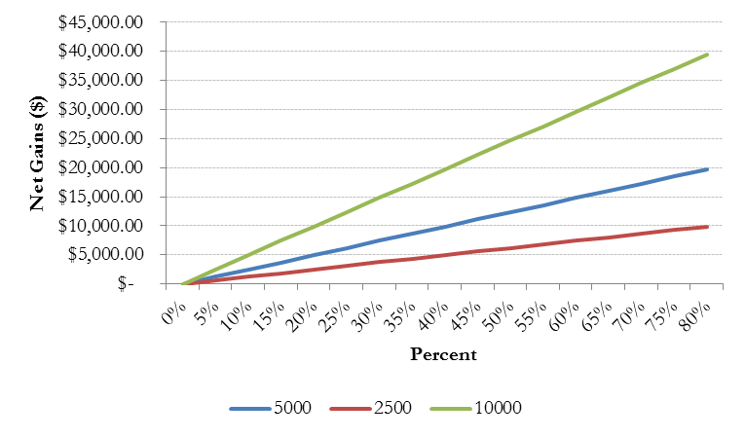

Scenario 2: Change in substitution
Table 3 Scenario 2 assumptions
Parameter | Value
Patient uptake | 40%
Practice Size | 5000
Rate of substitution | 0-30%
Clinical queries per patient | 1.5
Time of avoided consults | 12 minutes
Subscription fee | $0
Online consultation fee | $0
Co-payment forgone | $30-39

Increasing the rate of substitution put downward pressure on the increased GP FTE driven by adopting the portal. For a 5000 patient practice with 40% uptake:
- Zero percent substitution caused a 0.138 FTE increase
- 10 percent substitution caused a 0.105 FTE increase
- 20 percent substitution caused a 0.072 FTE increase
- 30 percent substitution caused a 0.040 FTE increase
Interestingly net gains marginally increase for higher rates of substitution. This implies that the value of GP time released from a greater number of avoided in-person consults outweighs the foregone fee revenue.
Concerns practices may struggle financially through lost fee revenue are not supported, as long as practices can meaningfully utilise the released GP resources. Further these results suggest practices can tailor how actively they encourage their patients to engage in online clinical queries rather than in-person consults to suit their model of care without financial repercussions.

Figure 2 Change in GP FTE conditional on the rate of substitution
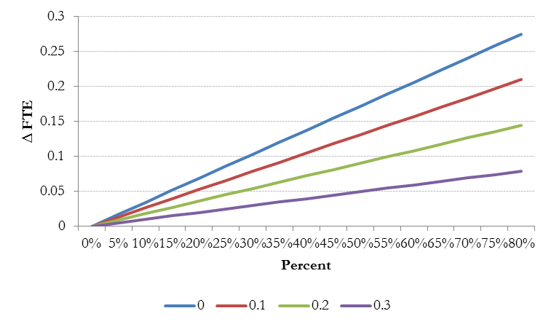

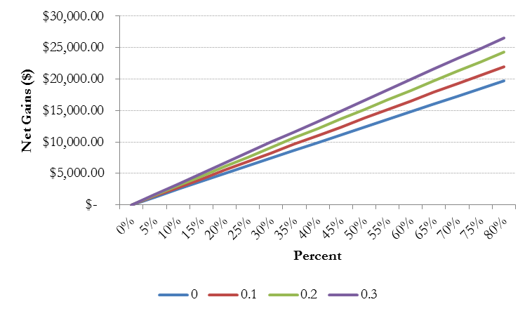
Figure 3 Change in net gains conditional on the rate of substitution

Scenario 3: Change in “clinical queries”
Table 4 Scenario 3 assumptions
Parameter | Value
Patient uptake | 40%
Practice Size | 5000
Rate of substitution | 10%
Clinical queries per patient | 1-2
Time of avoided consults | 12 minutes
Subscription fee | $0
Online consultation fee | $0
Co-payment forgone | $30-39

The number of clinical queries per patient has a considerable effect on both required GP FTE and net monetary gains. For a 5000 patient practice with 40% uptake, increasing the number of clinical queries per patient by 0.5 caused:
- GP FTE to increase by 0.037
- Net gains to decrease by $10,057
The disparity in outcomes for general practices increases with patient uptake.
Consequently, substitution in GP workload is crucial to counteract the adverse effects for general practices from high volumes of clinical queries. This is explored in detail in the full report.

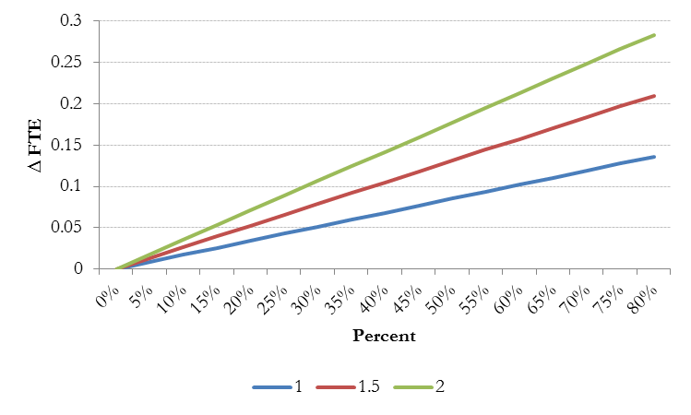
Figure 4 Change in GP FTE conditional on the number of clinical queries per patient

Figure 5 Change in net gains conditional on the number of clinical queries per patient
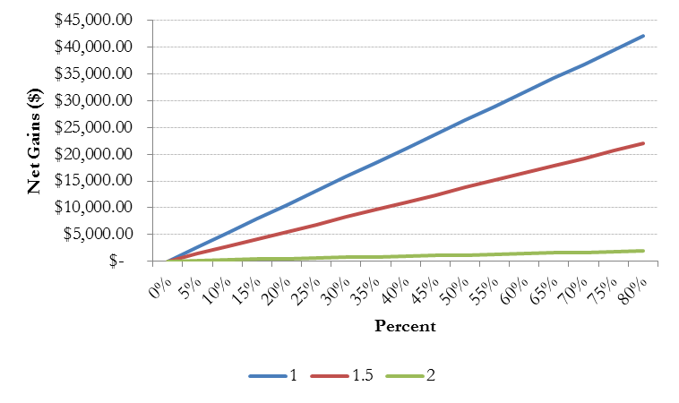

Scenario 4: Cost-recovery models
Table 5 Scenario 4 assumptions
Parameter | Value (subscription) | Value (pay-as-you-go)
Patient uptake | 20% | 40%
Practice Size | 5000 | 5000
Rate of substitution | 10% | 10%
Clinical queries per patient | 1.5 | 1.2
Time of avoided consults | 12 minutes | 12 minutes
Subscription fee | $20 | $0
Online consultation fee | $0 | $5
Co-payment forgone | $30-39 | $30-39

Table 5 outlines the assumptions for two different cost-recovery models: a) a subscription based scheme where patients are charged an annual fee for access to the portal; and b) a pay-as-you-go scheme where patients are charged a fee for engaging in clinical queries with their GP through the portal.
Subscription fees are likely to reduce uptake; we assumed uptake would be 50 percent less than without a subscription fee. This reduces the direct benefits of the portal for general practices. However the collected fee revenue appears to more than compensate practices.
Conversely, a pay-as-you-go fee is unlikely to slow uptake but could discourage patients from actually using the portal; we assumed the number of clinical queries per patient reduced by 20 percent. In this case, the direct benefits from the portal may increase (through a decrease in additional GP FTE) but the collected fee revenue is much less. There is less of an impetus to a different model of care in the practice.
The appropriateness of cost-recovery schemes will vary depending on the practice’s individual model of care, and how they wish to develop their model.

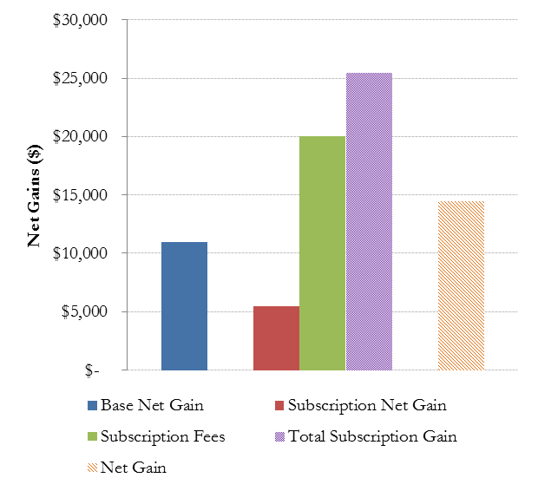
Figure 6 Financial outcomes under a subscription fee model

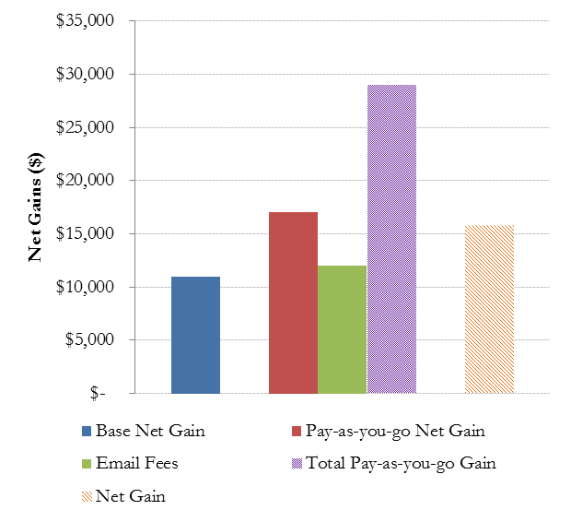
Figure 7 Financial outcomes under a pay-as-you-go model

Main points
- Patient portals have the potential to provide a net gain to general practice by releasing staff resources for more productive use;
- Portals have significant potential to redeploy practice staff time from low productivity tasks (phone conversations, taking notes, passing on messages) to more productive activity, such as running screening queries or operating nurse led clinics;
- Scale of uptake is important in achieving a large enough level of net gain to a practice;
- The effect is particularly strong for admin staff resources, but applies to nurse FTE as well;
- Clinical queries resulting from a patient portal do not swamp GP time - some additional GP time may be needed to deal with clinical queries coming through a portal, but the size of this is not large;
- Substitution of online clinical queries for some face to face consultations with co-payments can still result in a net gain in resource to a general practice, especially if the GP’s time saved from face to face consultations is redeployed doing something else which generates revenue;
- Copayment options for portal use, such as subscription models or fee for service payments for clinical queries, can result in significant new revenue for a practice, but have to be traded off against potential adverse effects on patient use of the portal, and consequently loss of some of the advantages of having it in the first place;
- The ability to redeploy clinical and administrative time within the practice has the potential to support models of care which are less focussed on sequential face to face consultations.

The forgone co-payments from avoided consults is a contentious issue and the outcomes for practices following any level of substitution will be conditional on the specific practices co-payments. Average co-payment fees charged across the practice were calculated and applied in the modelling. The broad report describes the calculations in detail.

