

ManageMyHealth
Lesson 10a. Booking your Appointment – Part one

Responsible | Sylvan Haeusler | Date | November 2016 | Version No. | 002
This is the appointments page:  To book an appointment:  - Select your GP from the drop-down box here:  - Select the day you wish to make an appointment using the calendar here:  - Select the time slot you require here:  - Then click ‘Confirm Appointment Request’.  Please turn over the page for instructions on how to complete your online appointment request. |  | 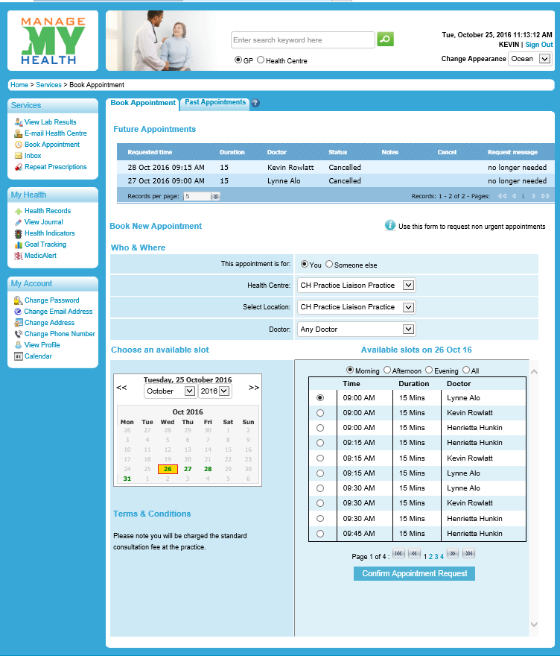  .

PTO
ManageMyHealth
Lesson 10b. Booking your Appointment – Part two

Responsible | Sylvan Haeusler | Date | November 2016 | Version No. | 002
Once you have clicked on ‘Confirm Request Appointment’ the following message will appear:  Terms and conditions for making, cost of attending and failing to attend your appointment will be displayed:  You may put a reason for your appointment in the following box (e.g. sore throat, twisted ankle).  Please Note: Any text you enter in the reason for the appointment box will be visible to all staff in the medical centre. Please do not enter any information of a sensitive nature.  Tick the box to accept the terms and conditions of making the appointment:  Finally – click on ‘Confirm your booking now.’  You will see a message on the screen that your appointment request has been sent. You will need to check your email to ensure your appointment has been approved by your medical centre. |  | 

