NZePS Quick Reference Guide – Medtech Evolution
- To prescribe a new medicine or to repeat a medicine, do as you would normally
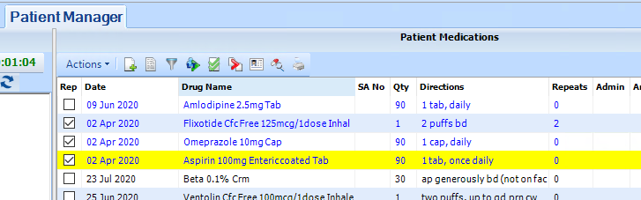
- The medicines selected will show up below the consultation box in the Details section
- The green button is to print the script, and this will automatically generate a barcode. The initials or name of the person who created the prescription will be at the beginning of the code
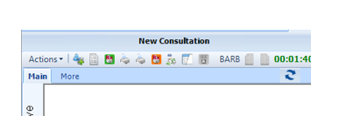
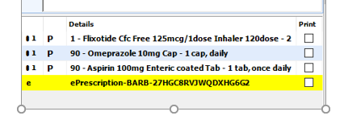

- To amend a prescription before it’s emailed or given to the patient, highlight the barcode and click the Rx icon. A Warning box will appear as a check that you do want to amend the script.
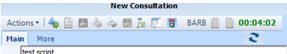

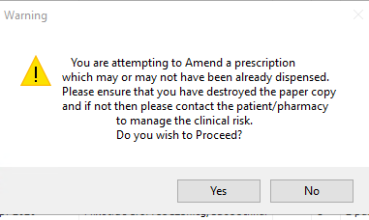
- To cancel a prescription before it’s emailed or given to the patient, double click the barcode to open the ‘View Single ePrescription’ view. Select medicine to be cancelled then click the Cancel

X.
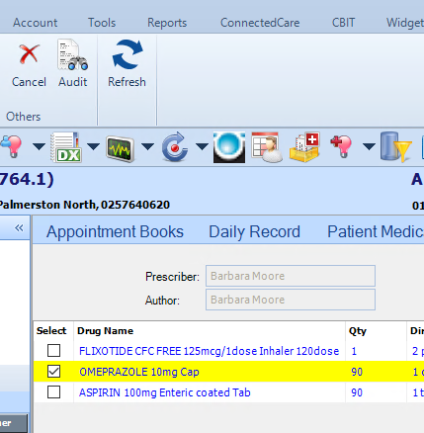
A warning box will appear asking if you wish to proceed. Click Yes & a 2nd box will appear with a drop-down options asking for the reason for the cancellation. You must select a reason to continue
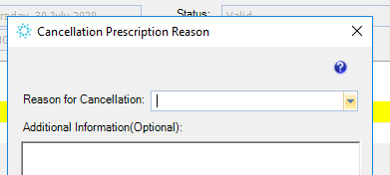

Print and Park Option for Nurses
- To repeat a medicine, do as you would normally making sure you change the prescriber’s initials. Be aware, your initials will show in the barcode.
- Click the Print & Park icon
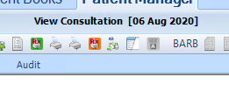
- The barcode will turn orange to indicate the script is available for the GP to review

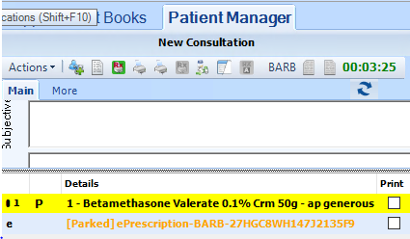
- DrInfo screen will appear – either print and give to GP for review, or can push cancel and task GP to review from the consultation record.
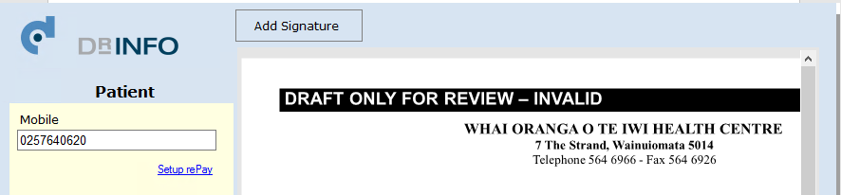

- If all OK, GP can push green print icon and DrInfo screen will appear so can email to pharmacy.
- If GP wants to amend an item, then click barcode to open the ‘View Single ePrescription’ view, select medicine to amend, make amendments and save. Go back to Details area, click green print icon and barcode will go black.

