Patient Portal Inbound and Outbound Traffic

1. Click on the MMH icon in MedTech to go to MMH
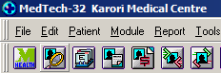

2. Click on usage stats in MMH

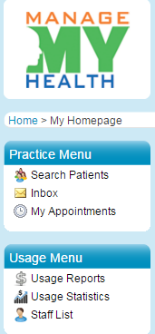

3. Click on usage statistics

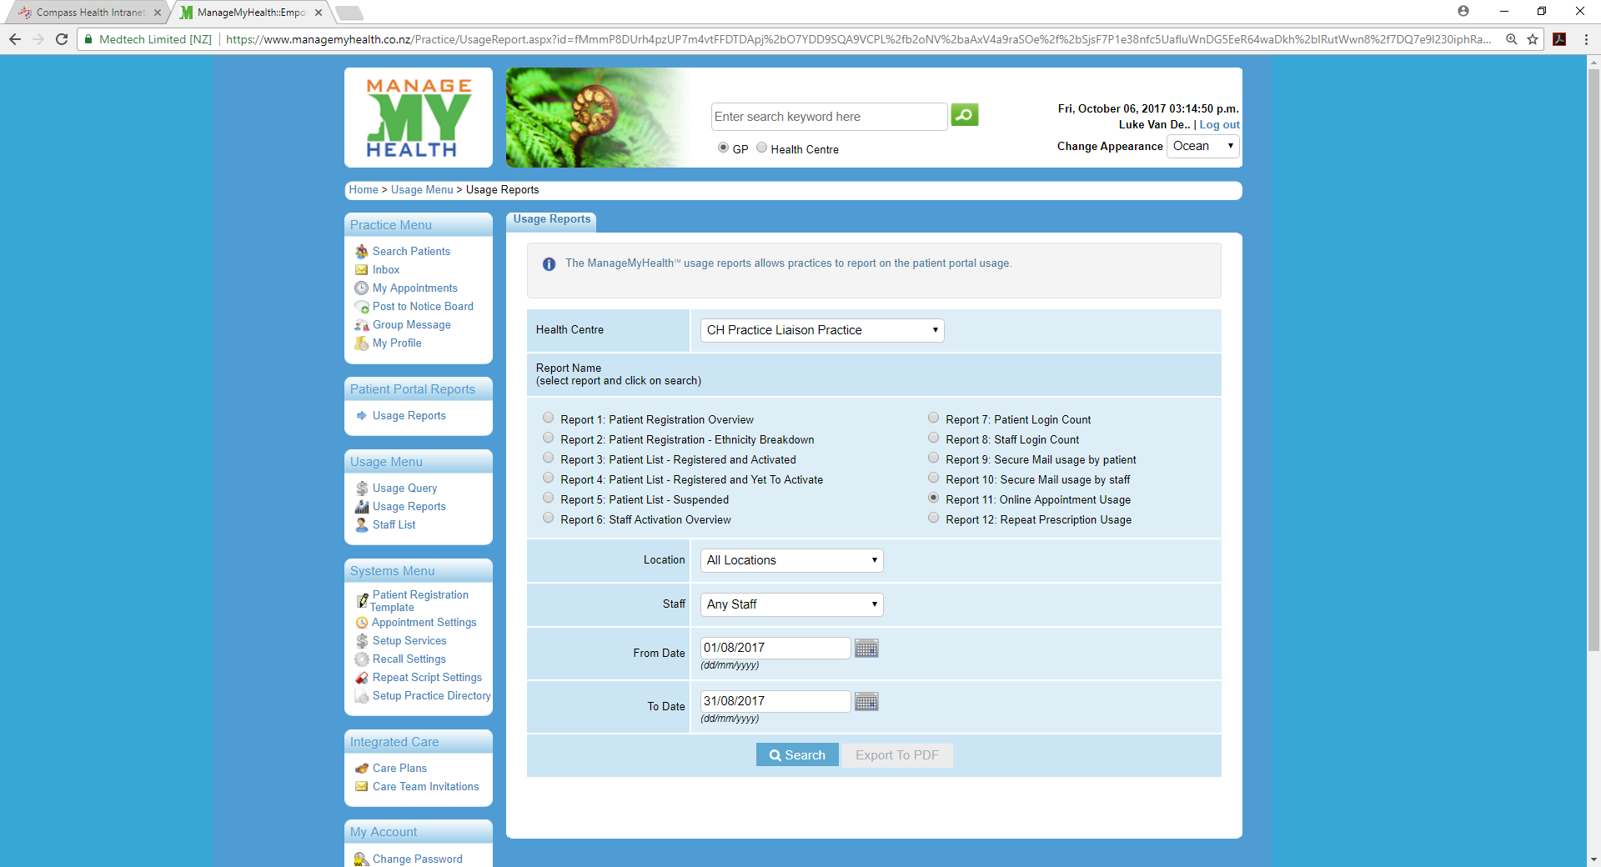
Click report 2 for ethnicity breakdown for Maori and Pacific

4. Once the window above is opened:
- Click on Report 9 and Report 10
- Enter the dates for the period required

